# CS 4320 Final Project: Requirements Analysis & Software Design

## OCDX Engine

### [GitHub Repository](https://github.com/holtwashere/CS4320-FinalProject)

### [Deployment Environment](http://ec2-35-161-12-137.us-west-2.compute.amazonaws.com/index.php)

### Team 4 Members:

Holt Skinner *Project Manager*

Justin Hofer

Ali Raza

Bo Zhang

Bradley Rogers

Pramod Pudotha

---

# 

# Table of Contents

* (Page 3) Requirements Analysis
  + User Descriptions
  + Use Cases
  + Functional Requirements
  + Non-Functional Requirements
    - User Non-functional
  + System Requirements
  + User Requirements
* (Page 4) Software Design
  + Sketches
  + Data
* (Page 5) Sprint 1
  + Updates
* (Page 5) Deployment Enviornment
* (Page 5) Testing
* User Acceptance Test (UAT) Scenarios
  + Data Scientist Uploads Manifest
  + Data Scientists Review Manifest
  + Data Scientists Search for Manifest
  + Data Scientists Notify Changes to Other Users
  + System Admin Bans an Illegal Data Scientist
  + System Admin Deletes an Illegal Manifest
  + User Experience
* Unit Test Scenarios
  + Login Function
  + Search for Manifest Function
  + Upload Function
  + Download Function
  + Edit/Delete Manifest Function
  + Failure Case
* Regression Testing
* Integration Testing
  + User Uploads Manifest
  + User Reviews Manifest
  + System Admin Bans an Illegal Data Scientist
  + System Admin Deletes an Illegal Manifest
  + Failure Case
* Summary
* (Page 8) Sprint 2 Updates
  + Database
    - The python code for inserts, updates, searches, and deletes.
    - Unit tests for these functions
  + User Interface
  + User Accounts
  + Business logic
  + Testing2
* (Page 14) Appendix
* (Page 18) Change Log

# Requirements Analysis

## User Descriptions

*Rogers*

* **Data Scientist**
  + Uploads and downloads data
  + Conducts sophisticated and systematic analyses of data
  + Extracts insights from large data sets
* **System Administrator**
  + Review the uploaded data
  + Manage users

## Use Cases

*Skinner/Hofer*

* A Data Scientist can Browse by keyword for Manifest
* A Data Scientist can Search on Manifest
* A Data Scientist can Contribute to Existing Dataset
* A Data Scientist can Download Info
* A Data Scientist can Generate or Upload Manifest
* A Data Scientist can Save - A Data Scientist can Upload Data Set

## Functional Requirements

*Skinner*

* The system will take an inputted manifest and place it into storage.
* The system will retrieve a manifest from storage and present it to a Data Scientist.
* The user interface can accept and serve search, upload, and update requests to and from Data Scientists.
* The system will process search, upload, and update requests, both into and out of Database Layer.

## Non-Functional Requirements

*Hofer/Raza*

### User Non-functional

* Data Scientists will be able to perform efficient searches based on keywords. Users should not wait more than about two seconds for a query to resolve.
* Data Scientists will be able to upload and update manifests.
* Data Scientists will be able to upload and download data files.

## System Requirements

*Raza/Hofer*

**Space Requirements**

* The system must have enough physical space to handle extremely large data-sets.
* The system may need to be a distributed system using clusters for efficiency.

**Reliability Requirements**

* If the system crashes, the data and any manipulations/analytics must be preserved.

**Privacy Requirements**

* The data access must be limited to authorized users only.
* The system must enable secure data transfer over the internet.

**Web Server**

* Web Server must provide reliable service for the appropriate amount of traffic that will be sent and received from the system.

**Database Backend**

* Database must be able to convert data into easily storable format, and return in original format.

**Storage Array**

* System must create intermediate backups and update logging to revert to earlier states if needed.

## User Requirements

*Zhang/Rogers*

* Data scientists will be able to upload Manifest.
* Manifest can be reviewed by other data scientists.
* Data scientists can edit or delete their Manifest.
* Data scientists can search for Manifest they wish to view or test.
* Data scientists will be able to include special comments or suggestions on manifest.
* Data scientists should be able to notify the changes or suggestions that improves manifest to other users.
* System admins can ban an illegal data scientist.
* System admins can delete an illegal manifest.

# Software Design

## Sketches

*Skinner/Rogers*

**Upload New Manifest(s)**

From this page, a Data Scientist can upload a new manifest and scripts, set a title for the manifest and set a description.

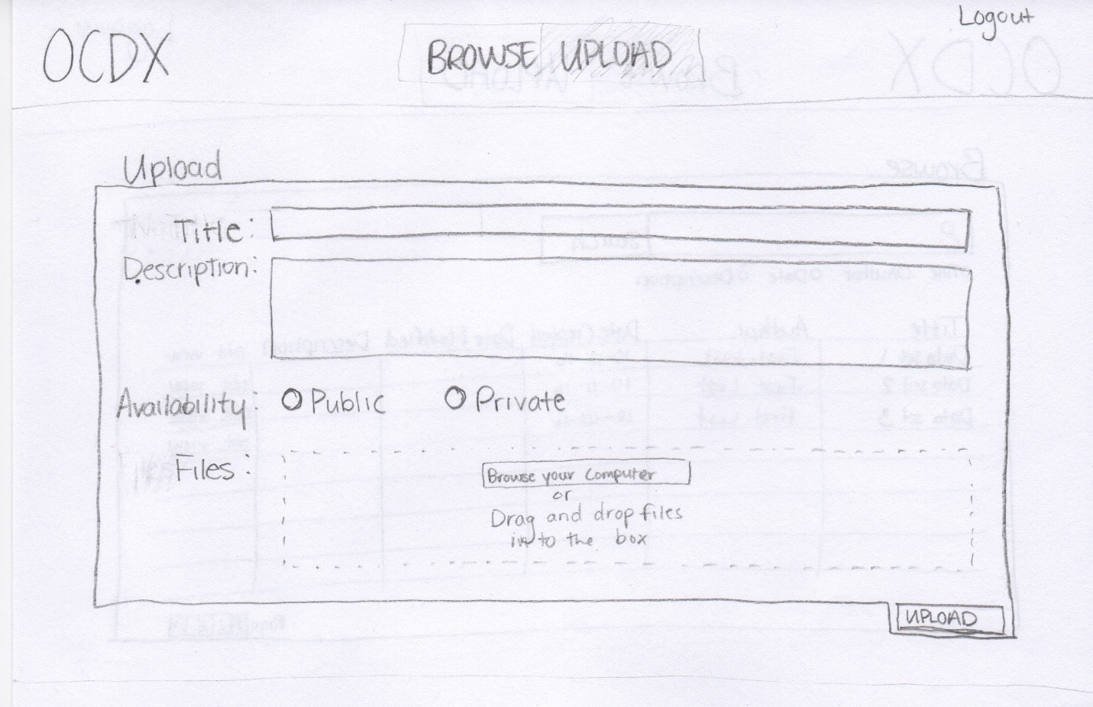

**Browse Uploaded Manifests**

A Data Scientist can search and browse uploaded manifests.

Data Scientists can organize the search results by Title, Author, Date or Description.

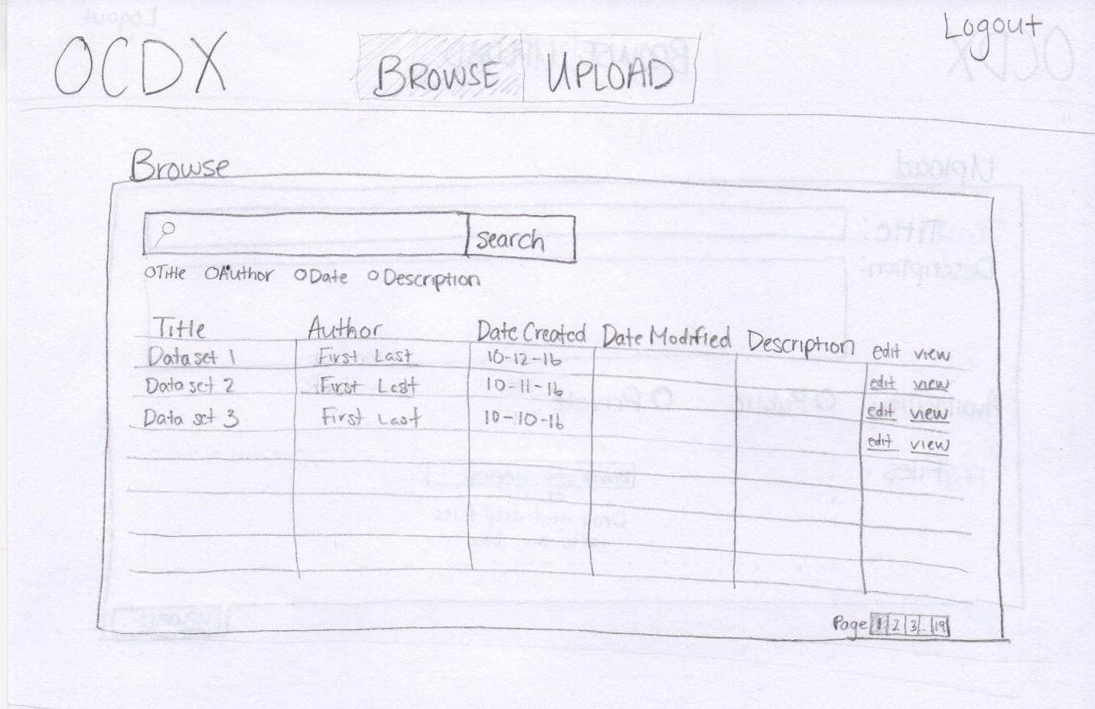

**Manifest Description/Edit Manifests**

This page provides the full information for a given manifest.

A data scientist can view the important information about a manifest including the Title, Author(s), and description.

A data scientist can contribute to a manifest if they have permission to do so.

A data scientist can download uploaded files from a given manifest.

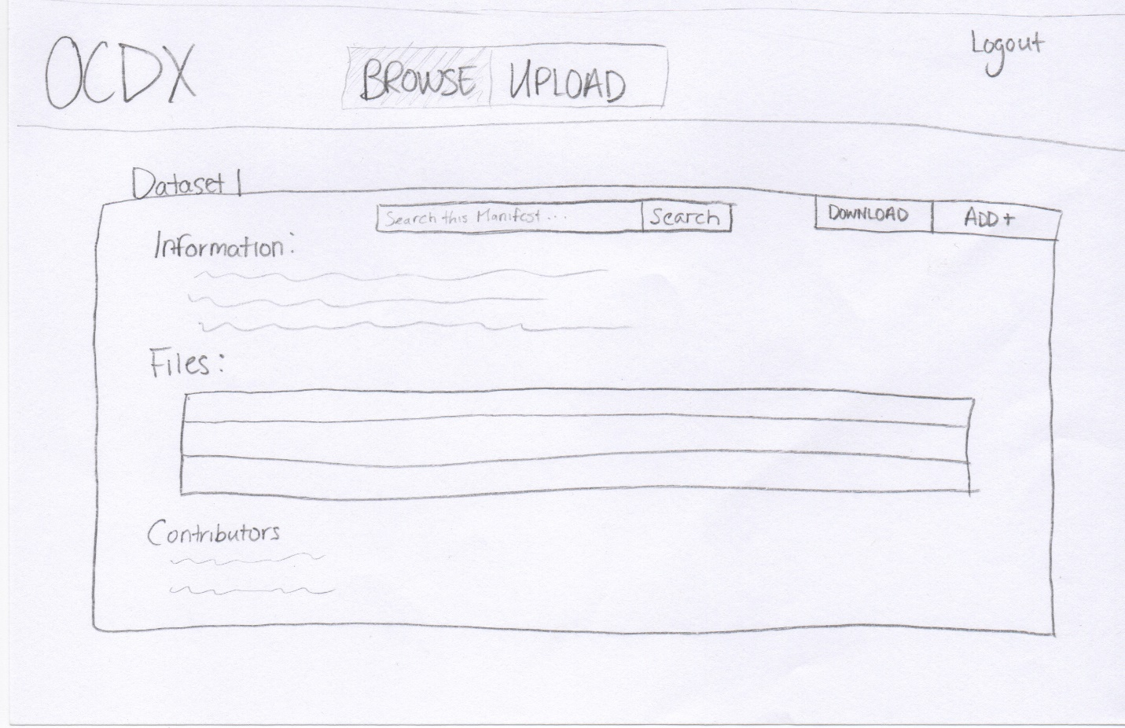

## Data

*Zhang/Hofer*

* **Members**
  + ID
  + name
* **OCDX_manifest**
  + author
  + date
  + size
  + category
  + version
  + modify_request
* **Users**
  + ID
  + name
  + email
  + phone
* **Login_attempts**
  + userID
  + date
  + attempts

## Database Design

*Hofer*

MongoDB Pseudo-ERD

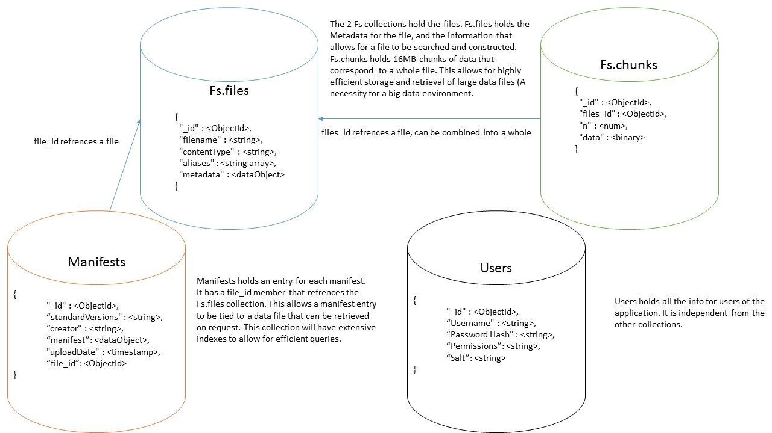

# Sprint 1 Updates

## Deployment Environment

*Raza*

* Hosting Platform: [Amazon Web Services](https://aws.amazon.com/)
* Operating System: [Ubuntu 16.04.1](http://releases.ubuntu.com/16.04/)
* Web Server: [Apache HTTP Server 2.4](http://httpd.apache.org/docs/current/)
* Database: [MongoDB](https://www.mongodb.com/)

## Testing

*Zhang/Hofer*

1. Build user acceptance test scenarios for documented requirements on separate Wiki page, linked to all sprints.
2. Build unit test scenarios.
3. Describe regression testing and your regression testing plan.
4. Describe how your team will perform integration testing. What needs to be integrated? When?
5. Describe which tests are for verification and which tests are for validation.

## User Acceptance Test (UAT) Scenarios

## Data Scientist Uploads Manifest

* The user enters the upload page, selects file from local directory and uploads manifest to the server.

## Data Scientists Review Manifest

* The user selects a manifest and review it. The required manifest is sent in response to query.

## Data Scientists Search for Manifest

* The user searches a manifest by keywords, the results can also be limited by time and author filters.

## Data Scientists Notify Changes to Other Users

* The data scientist sends a notification about changes to the author.

## System Admin Bans an Illegal Data Scientist

* The data scientist account is transferred to the "banned" group. A notification is sent to the user as well as the reason for the ban.

## System Admin Deletes an Illegal Manifest

* The manifest is deleted (moved to "trash" group), and a notification and reason are sent to its author.

## User Experience

* The stability of the system is acceptable.
* The reaction time is short.

# Unit Test Scenarios

## Login Function

* If the user exists, the action continues.
* If the user does not exist, further action is denied and the error message is shown.

## Search for Manifest Function

* The system finds the record from database by matching the keywords.
* The system returns an error message if no record is found.

## Upload Function

* The file is stored in the database.

## Download Function

* The required file is pulled from database and presented to the user.

## Edit/Delete Manifest Function

* The manifest is changed and database is updated.

## Failure Case

* Error message is displayed. The expected value and return value are compared.

# Regression Testing

* Regression testing is a type of software testing that verifies that software previously developed and tested still performs correctly even after it was changed or interfaced with other software.
* In this system, a set of unit tests are prepared to cover all the functions of the software. The tests are run after every update or bug fixing.

# Integration Testing

* Integration testing is the phase in software testing in which individual software modules are combined and tested as a group.
* We will perform integration testing after unit tests. It tests how the website responses to a user behavior.

## User Uploads Manifest

* The user can sign in, and choose the file to be uploaded, after the system check the file, the file is uploaded and the success message shows.

## User Reviews Manifest

* The manifest is searched on the server. If it is still valid, it is extracted from database and shows to the user.

## System Admin Bans an Illegal Data Scientist

* The data scientist account is transferred to the "banned" group. A notification is sent to the user as well as the reason for the ban.

## System Admin Deletes an Illegal Manifest

* The manifest is deleted (moved to "trash" group), and a notification and reason are sent to its author.

## Failure Case

* The system returns an error page when the required page is not found, or the server is down.

# Testing Summary

* The unit testing, integration testing and regression testing are for verification, the user acceptance test is for validation.

# 

# Sprint 2 Updates

## Database

*Hofer/Raza*

The database interface, written in python, allows for easy use of insert, update, search, and delete functionality for the database. Error checking is implemented to ensure that database integrity is maintained. Document Validation (Encoded by the creation statements) will check that all manifests are up to standard, and as such, do not need to be checked by the dml (Although they should be checked in the business layer). The Unit tests validate these functions, and will ensure that they are valid throughout creation of the system. The database also no longer has a user collection, as it is no longer required for login. As such, the user collection has been removed (Including from the ERD). The ERD also now uses Crows Feet notation to represent relationships, and required fields are marked.

### Updated Pseudo-ERD

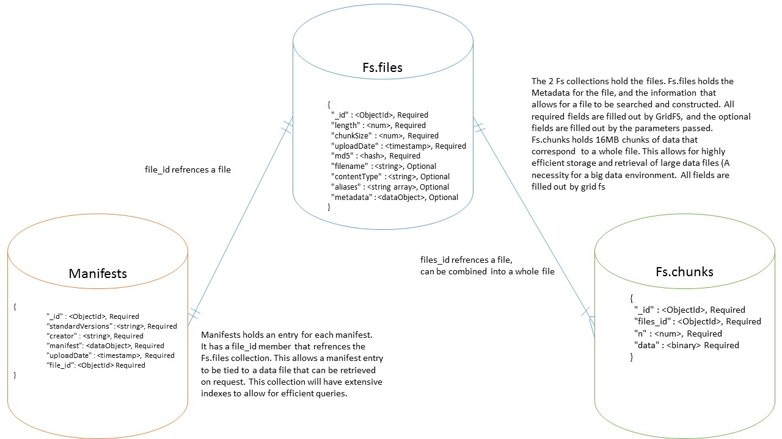

### The python code for inserts, updates, searches, and deletes.

from pymongo import MongoClient #Mongodb functionality  
  
 #initialize to the collections that we want  
 client = MongoClient()  
 db = client.test  
  
 m_col = db.Manifests #the collection of manifests  
  
 def search_manifest(lookup):  
 ''' finds all manifests that match pattern provided and returns the cursor of results  
 Returned value is a cursor that can be iterated through with a for loop '''  
 return m_col.find(lookup)  
  
 def insert_manifest(manifest):  
 ''' Insert given manifest if it exists. Returns True on success,  
 or False on error (Failed document validation or no manifest was passed in) '''  
 if(manifest): #basic error checking  
 post_id = m_col.insert_one(manifest)  
 ''' we have the object id for the new manifest, and we could return it if we like  
 We could also return a tuple containing the Boolean value and the object id  
 This way we could later do a lookup on the manifest, which would give us  
 access to its metadata. As we do not have any important metadata at the  
 moment, we will just give a simple error check '''  
 if(post_id):  
 return True  
 return False  
  
 def remove_manifest(oid):  
 ''' Delete manifest specified by internal object id. Access this object id  
 within the manifests metadata. returns True on succesful delete,  
 or False if unable to delete (No matching oid, no oid provided) '''  
 if(oid):  
 ''' Delete based on oid. Only can fail if the oid is invalid  
 In which case, wow, we are corrupting our own metadata somewhere  
 in the business logic or the view. At least we would know that we have  
 an error '''  
 result = m_col.delete_one({'_id': oid})  
 if(result.deleted_count == 1):  
 return True  
  
 return False  
  
 def update_manifest(oid, manifest):  
 ''' Updates the manifest specified by the given internal object id.  
 Changed to match the new manifest provided. Returns True  
 if the document was succesfuly updated, and returns False if it  
 failed. '''  
 if(oid and manifest):  
 #We actually want to remove the old manifest, and replace it with a new one  
 old_doc = m_col.find_one_and_replace({"_id": oid}, manifest)  
 #the old manifest was returned, so we can store an archive of manifests down  
 #the road. For the monent, we will just check that something was there before  
 if(old_doc[0]):  
 return True  
 return False

### Unit tests for these functions

from dml import insert_manifest, remove_manifest, update_manifest, search_manifest  
  
 to_insert = {  
 "manifests": {  
 "manifest": {  
 "standardVersions": "ocdxManifest schema v.1",  
 "id": "https: //datahub.io/dataset/iDas",  
 "creator": "Ali Raza",  
 "dateCreated": "2016 - 10 - 27",  
 "comment": "First test manifest",  
 "researchObject": {  
 "title": "iDAS Manifest",  
 "abstract": "Data collected at the Interdisciplinary Data Analytics and Search lab at the University of Missouri by Computer Science researchers and Data Scientists.",  
 "dates": {  
 "date": {  
 "date": "2005 - 04 - 27",  
 "label": "start"  
 }  
 }  
 },  
 "privacyEthics": {  
 "oversight": {  
 "label": "No assertion"  
 }  
 },  
 "informedConsent": "No assertion",  
 "anonymizedData": {  
 "label": "No assertion"  
 },  
 "privacyConsiderations": "No assertion"  
 },  
 "provenance": {  
 "narrative": "The Interdisciplinary Data Analytics and Search (iDAS) lab is one of the many research labs operating out of The University of Missouri, Columbia. As the name implies, iDAS combines researcher across departments to achieve solutions to problems in academia. Founded in 2005 by Dr. Chi-Ren Shyu, iDAS researchers are primarily Computer Scientist, but the lab also works with Medical Doctors, Biologist, and Statisticians."  
 },  
 "publications": {  
 "publication": "No assertion"  
 },  
 "locations": {  
 "location": {  
 "url": "",  
 "comment": ""  
 }  
 },  
 "files": {  
 "file": {  
 "name": "iDAS - data.csv"  
 },  
 "format": ".csv",  
 "abstract": "Metadata for 5000 records collected",  
 "size": "No assertion",  
 "url": "No assertion",  
 "checksum": "No assertion"  
 },  
 "permissions": "No assertion"  
 },  
 "dates": {  
 "date": {  
 "date": "2014 - 02 - 15"  
 },  
 "label": "Created"  
 },  
 "creators": {  
 "creator": {  
 "name": "Chi-Ren Shyu",  
 "role": {  
 "label": "Other"  
 }  
 },  
 "type": {  
 "label": "No assertion"  
 },  
 "contact": "cshyu@wikimedia.org"  
 }  
 }  
  
 to_replace = {  
 "manifests": {  
 "manifest": {  
 "standardVersions": "ocdxManifest schema v.1",  
 "id": "https: //datahub.io/dataset/sociallyCompute",  
 "creator": "Sean Goggins",  
 "dateCreated": "2016 - 08 - 13",  
 "comment": "Second test manifest",  
 "researchObject": {  
 "title": "Socially Compute Manifest",  
 "abstract": "Data mined from socail networks for the purpose of consumer trend analytics.",  
 "dates": {  
 "date": {  
 "date": "1992 - 03 - 11",  
 "label": "start"  
 }  
 }  
 },  
 "privacyEthics": {  
 "oversight": {  
 "label": "No assertion"  
 }  
 },  
 "informedConsent": "no assertion",  
 "anonymizedData": {  
 "label": "No assertion"  
 },  
 "privacyConsiderations": "No assertion"  
 },  
 "provenance": {  
 "narrative": "Socially Compute is an ongoing project aiming to analyze trends of everyday people to make meaningful connections."  
 },  
 "publications": {  
 "publication": "No assertion"  
 },  
 "locations": {  
 "location": {  
 "url": "",  
 "comment": ""  
 }  
 },  
 "files": {  
 "file": {  
 "name": "Socially Compute - sc.csv"  
 },  
 "format": ".csv",  
 "abstract": "Metadata for 15000 records collected over two decades",  
 "size": "No assertion",  
 "url": "No assertion",  
 "checksum": "No assertion"  
 },  
 "permissions": "No assertion"  
 },  
 "dates": {  
 "date": {  
 "date": "2016 - 10 - 28"  
 },  
 "label": "Created"  
 },  
 "creators": {  
 "creator": {  
 "name": "Sean Goggins",  
 "role": {  
 "label": "Other"  
 }  
 },  
 "type": {  
 "label": "No assertion"  
 },  
 "contact": "sg@wikimedia.org"  
 }  
 }  
  
 #Insert the first test manifest  
 test = insert_manifest(to_insert)  
 if(not test):  
 print("Bad insert")  
 else:  
 print("Good insert")  
  
 #Ensure thata the manifest was inserted properly  
 found = search_manifest({})[0]  
 if(found['creators']['contact'] == to_insert['creators']['contact']):  
 print("Match")  
 else:  
 print("No Match")  
  
 #Update to Second manifest  
 test = update_manifest(found['_id'], to_replace)  
 if(not test):  
 print("Bad update")  
 else:  
 print("Good update")  
  
 #Ensure good manifest update  
 found = search_manifest({})[0]  
 if(found['creators']['contact'] == to_insert['creators']['contact']):  
 print("Did not replace")  
 elif(found['creators']['contact'] == to_replace['creators']['contact']):  
 print("Good Replace")  
 else:  
 printf("replace corruption")  
  
 #remove the manifest  
 test = remove_manifest(found['_id'])  
 if(not test):  
 print("Bad remove")  
 else:  
 print("Good remove")

## User Interface

*Skinner/Rogers*

* [Link](http://ec2-35-161-12-137.us-west-2.compute.amazonaws.com/index.php)
* The Homepage UI is functional.
* A Data Scientist will be able to search for manifests from the homepage and view details for the desired manifest through a link for each search result.
* Currently, the search results are dummy datasets until the database can be linked with the View.
* The GUI is developed using the Materialize framework for styling and JavaScript/jQuery for the front-end business logic.
* The navigation bar at the top of the page provides easy access to all main functions of the application.
* The "Login" button opens a Modal box that allows a Data Scientist to log in with a Google Account.

## User Accounts

*Rogers/Skinner*

* Implemented via Google's OAuth 2.0 API.
* A Data Scientist can log in with a Google account.
* A Google login page appears to the user, the user logs in with Google credentials.
* The Google API returns a unique user_id token, which is stored in the Database.
* Due to limited use cases, and limitations of the Google API, there is not a dedicated administrative user. Instead, all logged in data scientists have full read/write access.
* [Documentation](https://developers.google.com/identity/sign-in/web/)

## Testing Updates

*Zhang/Raza*

* Sprint1 Testing Updates
* Unit tests for the Database insert, update, search, and delete functions are implemented as a python script. (See Sprint 2, Database)

# Sprint 3

## Overall Task List (Sprints 1-3)

**Justin Hofer**

- Developed database structure

- Developed business logic structure

- Implemented document validation for manifests

- Implemented insert, search, update, and delete statements for manifests

- Developed all tests for database

- Implemented file logic

- Wrote ERD

- Database creation logic

- Validated seed data for database

- Helped with requirements document

**Holt Skinner**

- Project Manager

- Directed Tasks

- Facilitated Communications

- Documentation Compilation and Submission

- Transcribed Markdown Document to Microsoft Word and PDF files

- Compiled Initial Requirements Analysis Document

- Compiled All Sprint Documentation files

- Initial UI Implementation

- Designed Homepage and subsequent pages from Materialize Framework

- Created HTML, CSS, and JavaScript for Homepage

- Implemented Front-end "Login with Google" logic in JavaScript

**Bo Zhang**

- Designed and described all testing documentation

- Designed and implemented business logics for manifests

- Analyzed user requirements

- Replaced php calls with jQuery in Front-end Business logic

**Bradley Rogers**

* UI Design and Implementation

**Ali Raza**

System Administrator

- Deployed web server

- Setup user accounts

- Installed dependencies

- Installed required programs

Documentation

- Began User Documentation

- Created Temporal Logic

Business Logic

- Begin accepting user inserted values for manifests

**Pramod Pudotha**

* Did not participate

## User Interface Temporal Logic

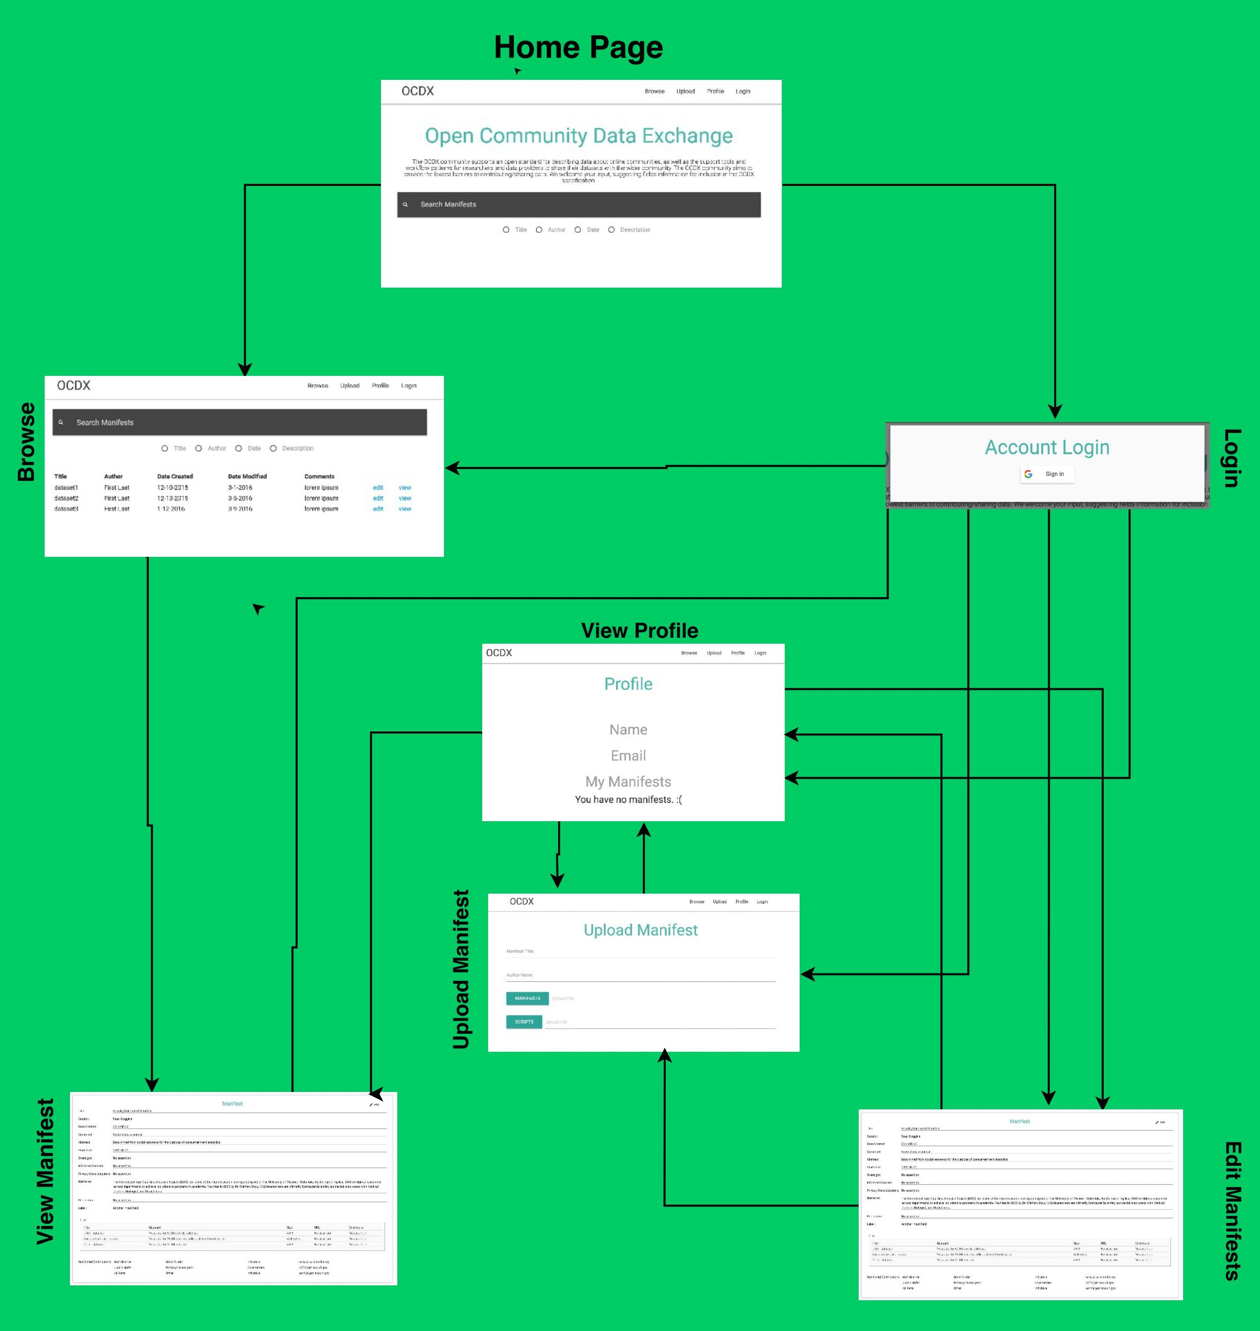

Complete

* Home Page/Search
* Browse
* View Profile
* Account Login
* Upload Manifest

Work in Progress

* View/Edit Manifest

Omitted

* Data Visualizations

## Testing Updates

## User Documentation

* See UserDocumentation.pdf

## Remaining Tasks for Sprint 4

* Convert remaining php scripts to python.
* Link database queries to user interface via python business logic.
* Add styling to View/Edit manifests pages in UI.

## Sprint Meeting Notes

### 11-15-2016

Members Present:

-Pramod

-Justin

-Brad

-Holt

-Ali

-Bo

Task List:

-Ali:

-Convert UI logic to python applications using flask

-browse.php

-header.php

-footer.php

-Begin User documentation

-Deployment documentation (Sprint 4)

-Justin:

-Gridfs for file system implementation

-Bradley/Holt:

-Continue front end design

-Pramod:

-Update documentation

-Holt:

-Documentation correction/formatting

Decisions:

-Convert php files to python

### 11-16-16

Members Present:

- Brad

- Bo

- Ali

Work Done:

- Ali began user documentation for sprint

- Bo is working on temporal logic for sprint 3

- Brad is working on the viewing/editing manifests

Decisions:

- Email Dr. Goggins for clarification on Manifest format

- Email has been sent.

- Currently waiting for response.

- Test whether PHP 5.4 works w/ Mongo

- Ali will do this on a separate server.

- If successful, we will downgrade PHP to 5.4 on production server.

- If not successful, we will convert PHP to Python/Flask

### 11-17-16

Members Present:

- Holt

- Brad

- Justin

- Ali

- Bo

Decisions:

- Allow users to insert manifest via JSON

- Give access to manifest specifications

- Make individual markdown of task list

- Implement Ajax calls to Python scripts

- Continue Grid FS implementation

- Temporal Logic (Ali)

Actions:

- Converted PHP include statements to jQuery

# Change Log

* Version 1.0: Pre-Implementation Design *10-16-2016*
* Version 1.1: Sprint 1 *10-31-2016*
* Version 1.2: Sprint 2 *11-11-2016*
  + Made Fixes/Changes to Initial Requirements Analysis/Design and Sprint 1 Documentation
* Version 1.3: Sprint 3 *11-18-16*
  + Made updates to Sprint 2 Documentation for Regrade.